**BCI Lab Report 6**

**Report:** Create a tone at 40Hz and listen to it.

Can you hear it?

* I was able to hear this pretty clearly. It sounded like a low tone.

What about a tone at 900Hz?

* I could hear this but it was fainter and higher pitched.

Based on your answer, explain in your report why we need to have carrier (900Hz) and modulator (40Hz) tones.

* Based on my reading we use a carrier in real life in order to efficiently propagate through a medium like air or radios. This is pushing the signal to a higher frequency in order for it to be easier to decode upon its arrival.[1]
* Then the modulator tone is encoded within the carrier. This is helpful because it's actually within the auditory range and the brain actually can synchronize with some stimuli around this frequency range.[1]
* The combination of these two frequencies creates beats as the sine waves counteract or sum with each other.
* The actual combined AM signal will show the carrier’s amplitude oscillating at the modulator's frequency. [1]
* Having the carrier also makes the 40 Hz tone easier to perceive due the carrier bringing it to a more audible frequency.

Include a plot of the first 100ms of each sound generated in 2e (carrier, modulator, AM signal). (7 pts)

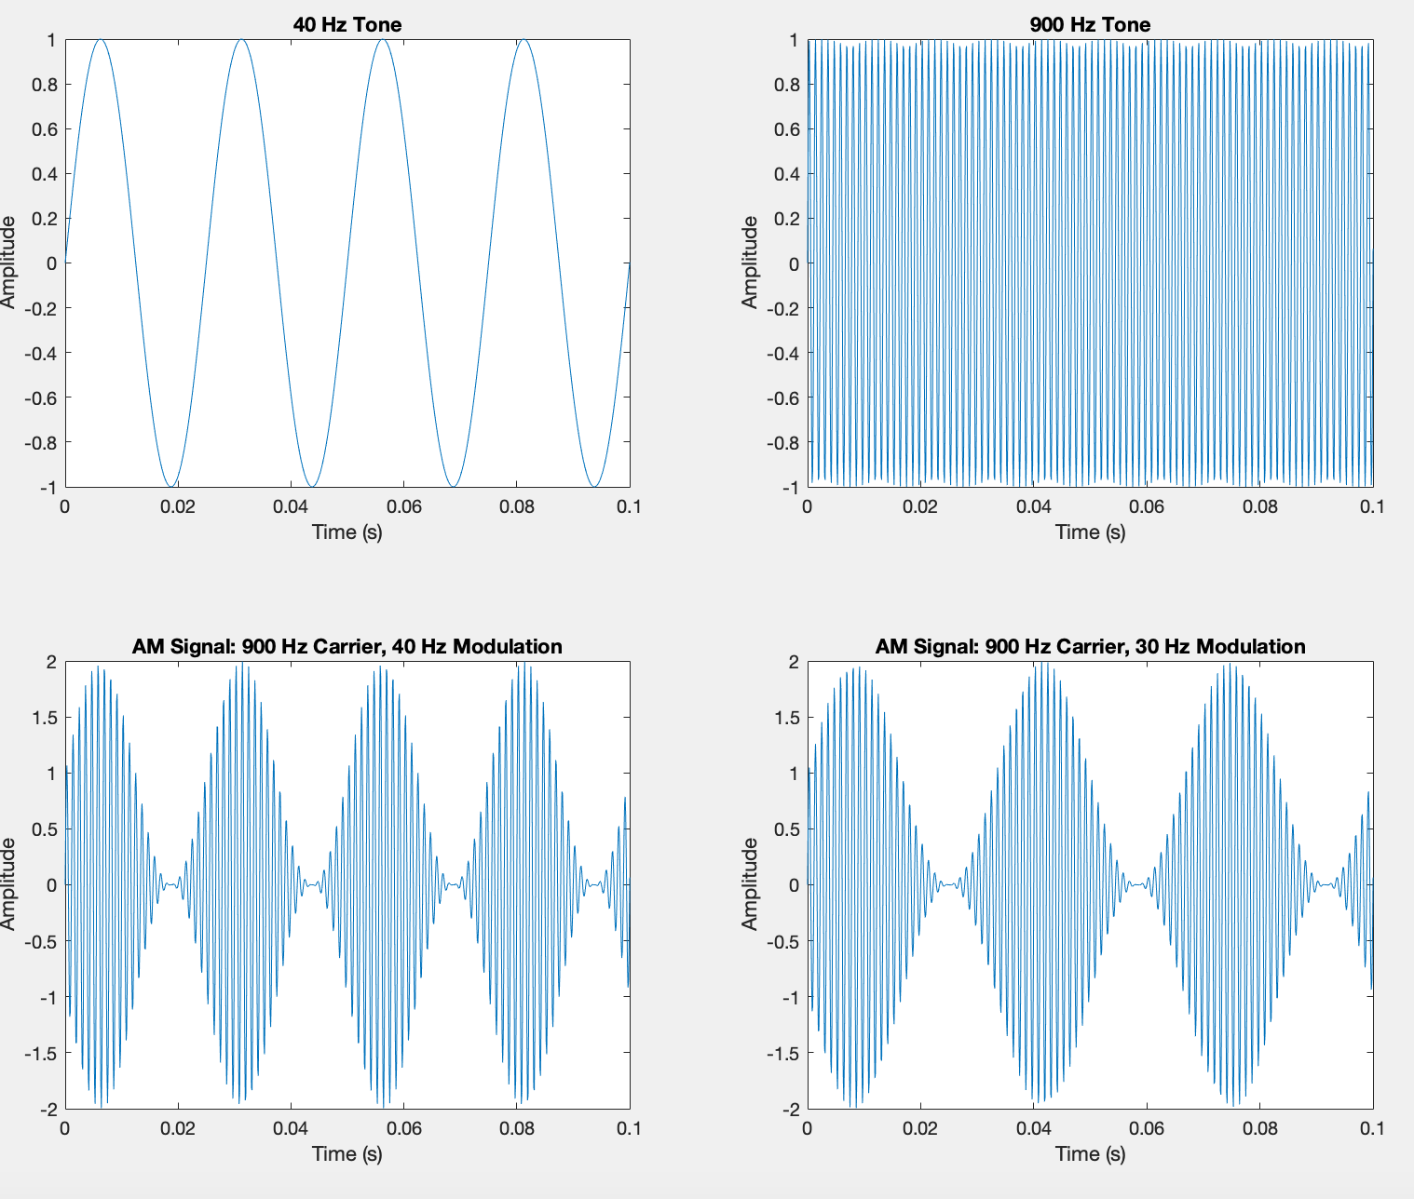

Report: Include a plot of the first 100ms of each sound (carrier, modulator, AM signal). (3 pts)

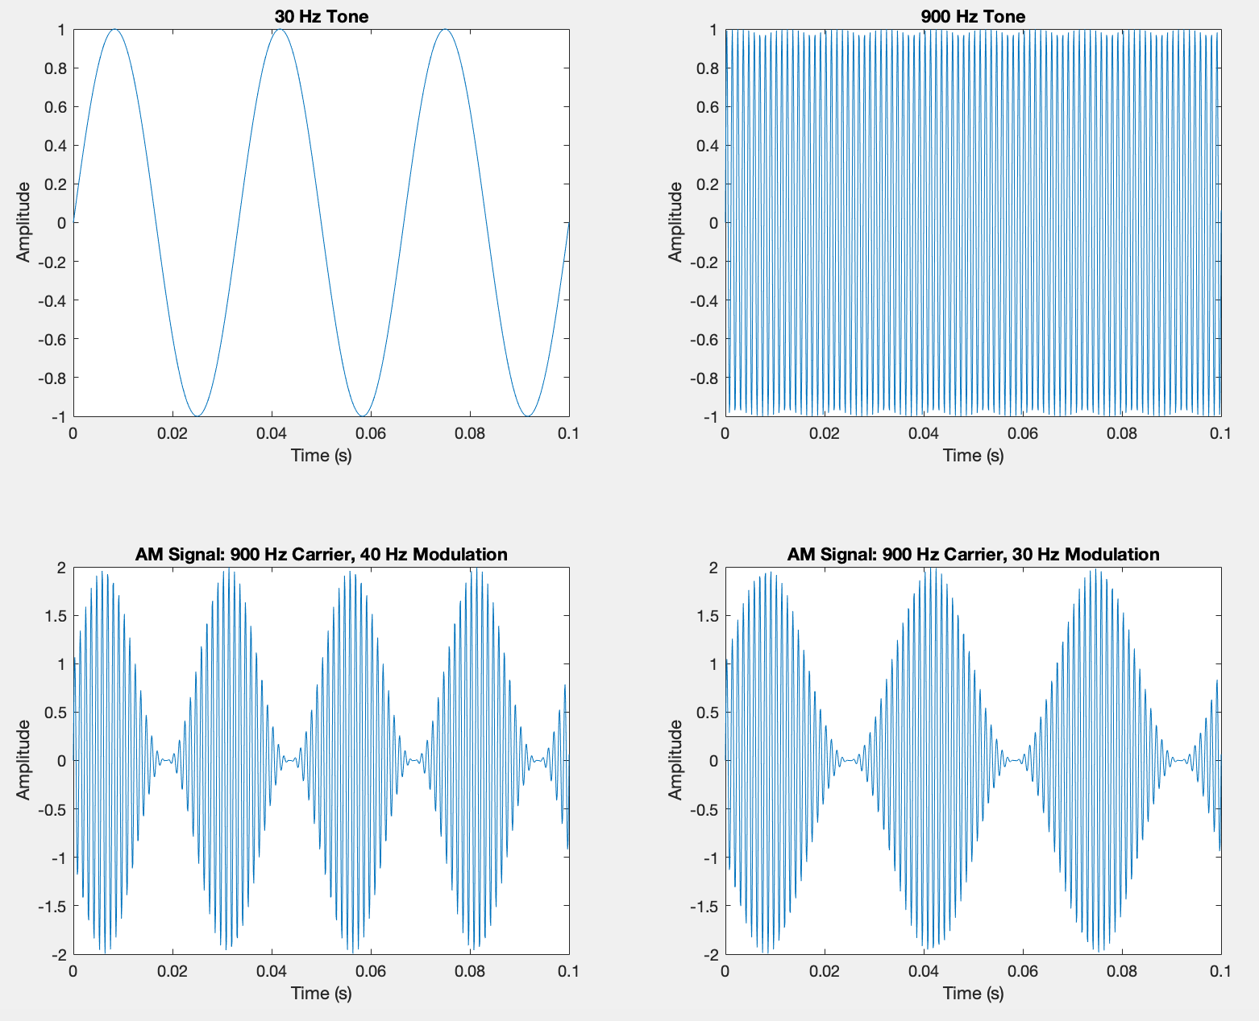

References:

[1]<https://hearingreview.com/hearing-products/accessories/components/auditory-steady-state-response-assr-a-beginners-guide#:~:text=Test%20frequencies%20of%20500%2C%201000,%3E80%2D90%20Hz>).